Archiving and Compression

Archiving and Compression Questions with Explanations

1. tar – Archive files Question 1: How do you create an archive named backup.tar that includes all files in the /home/user/documents directory?

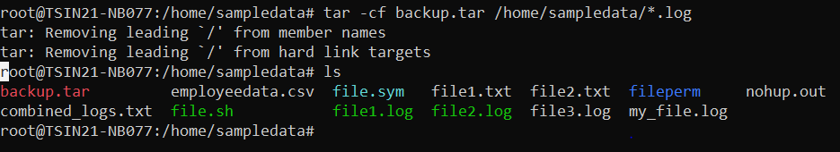

Question 2: How do you extract the contents of an existing archive backup.tar to the current directory?

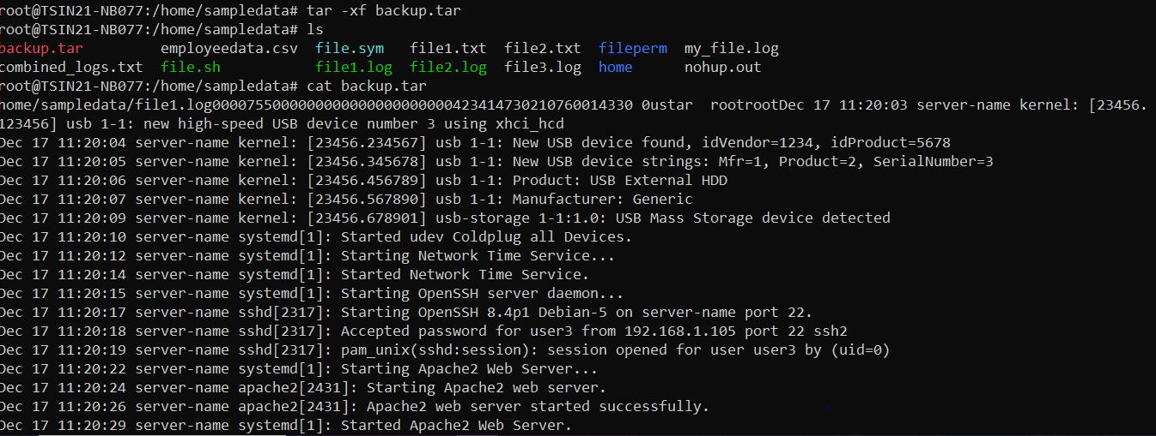

2. gzip / gunzip – Compress or decompress files using gzip

Question 1: How do you compress a file named file.txt using gzip?

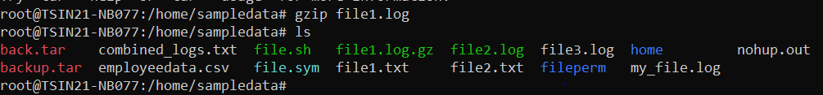

Question 2: How do you decompress a file named file.txt.gz ?

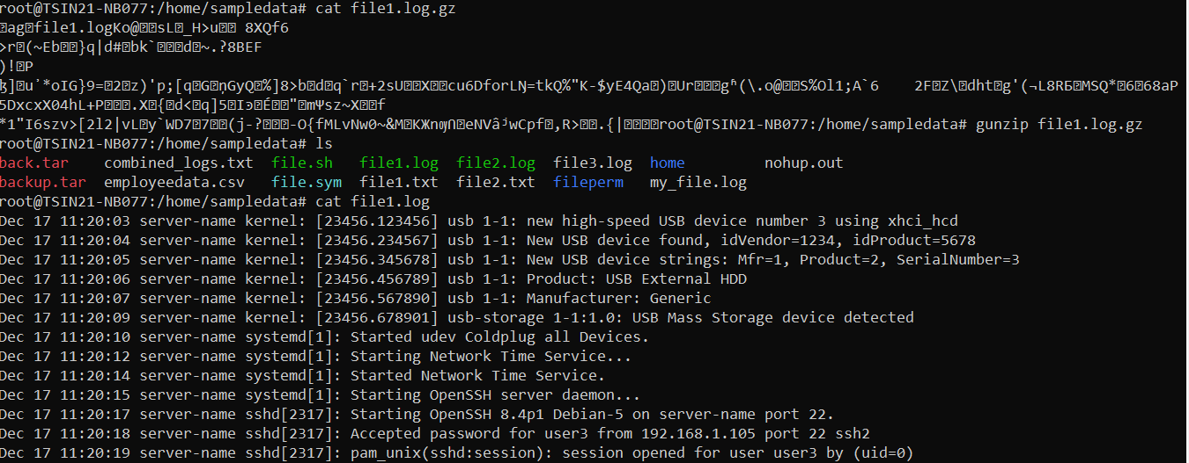

3. zip / unzip – Compress or decompress files using zip

Question 1: How do you create a zip archive named archive.zip containing multiple files, file1.txt and file2.txt ?

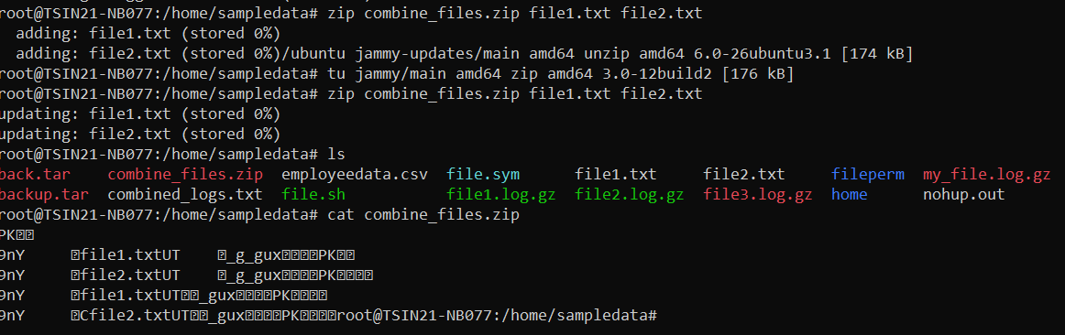

Question 2: How do you extract all files from archive.zip

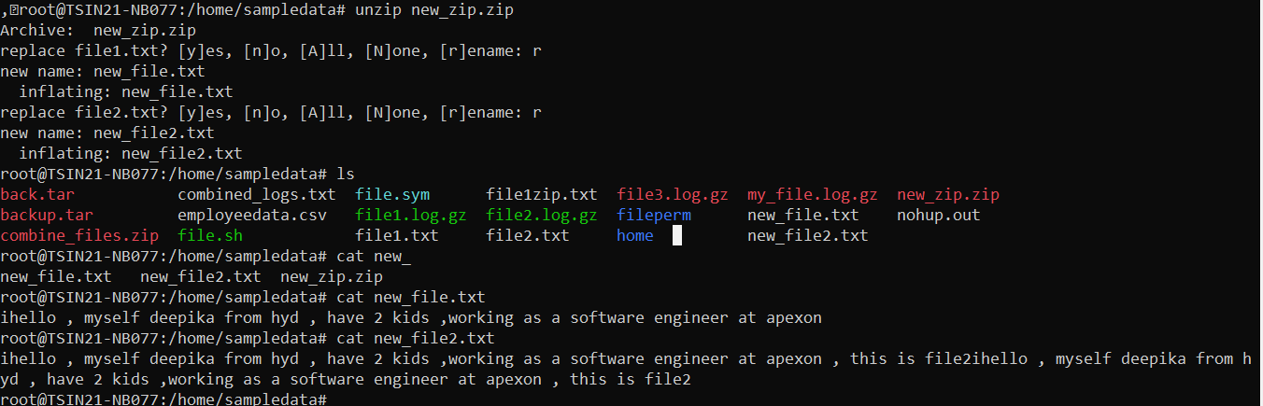

4. xz / unxz – Compress or decompress files using xz compression

Question 1: How do you compress a file named largefile using xz?

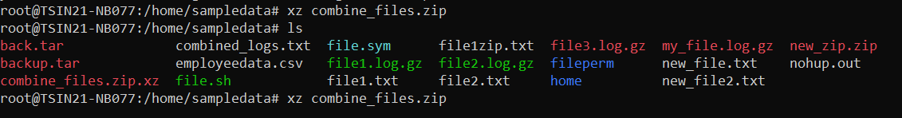

Question 2: How do you decompress a file named largefile.xz ?

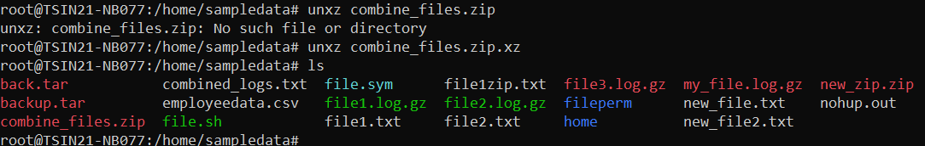

Combination Scenarios

Question 1: How do you create a compressed archive backup.tar.gz that includes files in /var/log?

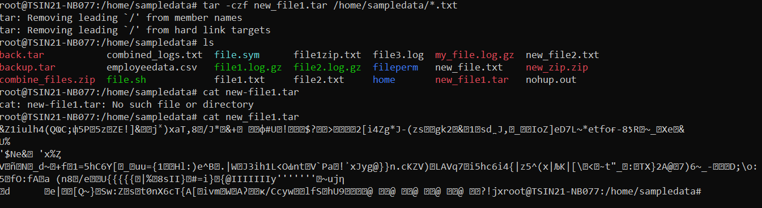

Question 2: How do you extract and decompress the contents of backup.tar.gz ?

